PAGB Inter Club Print Championship 2026

On Saturday 24th October, the PAGB Inter Club Print Championship 2026 was held at Harper Adams University, Shropshire. It was great that Vic, Chrissie, Roy and ourselves were able to attend the event and this was particularly helpful with the selections needed to be made on the day.
We had some high marks in the qualifying round, scoring 157 with our 12 prints and were in 12th place, an average of 13.0, agonizingly only 2 marks away from qualifying for the final round. Indeed, Arden the eventual winners of the entire competition finished =7th in the qualifying round, only 2 marks ahead of Colchester on 159.
So we headed into the plate competition, where we entered 8 prints (4 new) and we improved our average mark to 13.5, scoring 108 marks. Agonisingly the joint winners of the plate scored 109 marks, we were 1 mark away from being joint winners of the plate and being invited back automatically next year.
Although it is slightly disappointing to have been so close, the standard is incredibly high and we are actually able to compete and hold our own with some very renowned clubs which is something we can all be proud of.
Congratulations to the following authors whose prints achieved 14 or more

Cheetah Family in early morning sun (15)  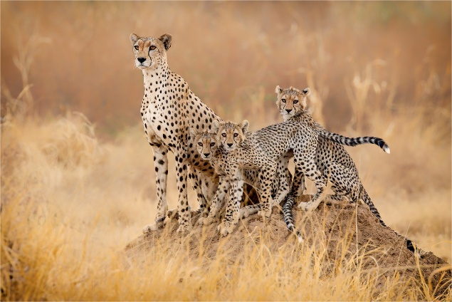  Derek Howes | Room with a View (14)  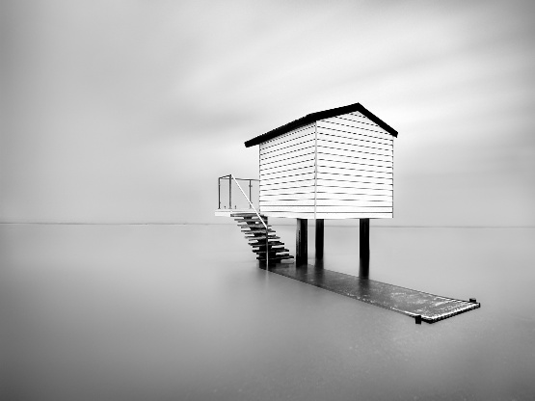  Chris Aldred
Just Chilling (14)  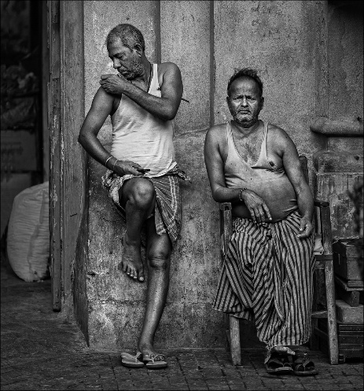  Roy Essery | Way to the Highlands (14)  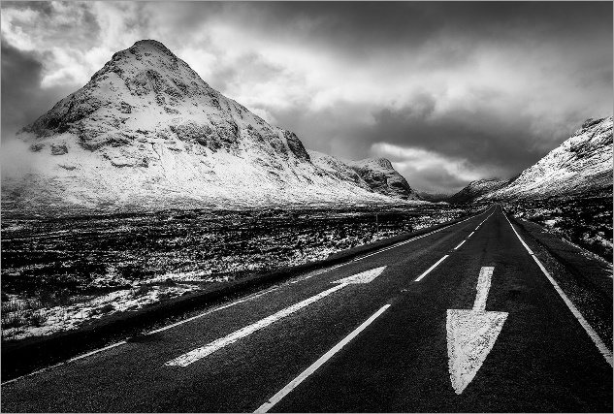  Roy Essery
Qualifying Round

Title | Author | Mark
Elephant and Calf | Chrissie Hart | 13
Aladdin | Roy Essery | 13
Starling Scrap | Chris Aldred | 13
Room with a View | Chris Aldred | 14
Just Chilling | Roy Essery | 14
Chance Encounter | Chrissie Hart | 13
On the edge of the mist | Andrew Bailey | 13
Boy of 26 | Roy Essery | 13
The Girl, a coke bottle and the face of Dior | Martin Heathcote | 12
Abandoned Farm, Iceland | Colin Westgate | 12
God Save the Freaks | Chrissie Hart | 12
Cheetah Family in early morning sun | Derek Howes | 15

Plate Competition

Title | Author | Mark
Way to the Highlands | Roy Essery | 14
Room with a View | Chris Aldred | 14
Geese at Herringfleet Mill | Andrew Bailey | 13
Just Chilling | Roy Essery | 14
Grey Heron – a moment in flight | Andrew Bailey | 13
Wash Day | Chrissie Hart | 12
Chance Encounter | Chrissie Hart | 13
On the edge of the mist | Andrew Bailey | 13
Cheetah Family in early morning sun | Derek Howes | 15

I would like to thank all of the club photographers for helping me by supplying me with prints and in some cases, printing images especially. Once again, my apologies if, on this occasion, I was unable to use your print. Only 16 of the bank of 50 prints were used and the critical decision is to try to select images that you feel the judges will score highly, which we were largely able to do. On the day you get a feel for what is doing well and this broadly dictates the sort of image you try in the next round.

This was our fourth successive year competing at the highest level of club print photography and naturally now, our resources are a little depleted. I encourage all members to strive for good new images over the next couple of months - and to keep me posted as new images become available.

If you would like to be able to have an image selected but have not succeeded so far, please do not give up! I suggest that you make contact with me and also consider coming to the EAF Championships to be held at Fulbourn on 14th March 2027, so that you can become familiar with the standard and the types of images that tend to do well.
Click here for the full results Inter Club Print Championship – The Photographic Alliance of Great Britain
Andrew Bailey
External Competition Secretary

