Colchester Photographic Society 8x8 Competition Tuesday 20th October 2026
Judge: Ben Pike

On Tuesday 20th October, we enjoyed the 8 by 8 competition at Christ Church. This was a nail biting affair, with Ipswich racing into a 4 point lead at the break, with some high quality prints on display from all of the participating clubs.
With work to do after the break, we needed a couple of 20s to bring us back into contention and to our delight ‘Chance Encounter’ by Chrissie Hart and ‘Just Chilling’ by Roy Essery added to our earlier maximum score achieved by ‘Model Interior’ by Jeff Scott. Fortunately for us the other clubs all had lower marks in the second half and we completed our comeback with a 3 point winning margin over Clacton.
Thanks to all members who helped to put on a delightful buffet in the interval and for being so welcoming with our guests from other clubs.

The final positions were
1 | Colchester PS | 148
2 | Clacton | 145
=3 | Chelmsford | 143
=3 | Ipswich and District PS | 143
5 | Halstead | 141
6 | Maldon | 136
7 | Harwich | 133
8 | Great Notley | 132

The Best Print award went to Chrissie Hart for ‘Chance Encounter’.

Our prints fared as follows

Whitby Abbey | Peter Pangbourne | 17
Abandoned Farm, Iceland | Colin Westgate | 18
Model Interior | Jeff Scott | 20
Room with a View | Chris Aldred | 16
Grey Heron in Flight | Andrew Bailey | 18
Just Chilling | Roy Essery | 20
Chance Encounter | Chrissie Hart | 20
The Girl, a Coke Bottle and the Face of Dior | Martin Heathcote | 19

Colchester’s images that were used on the night

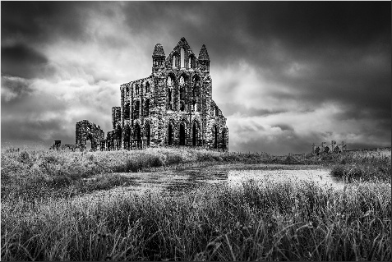  Whitby Abbey | 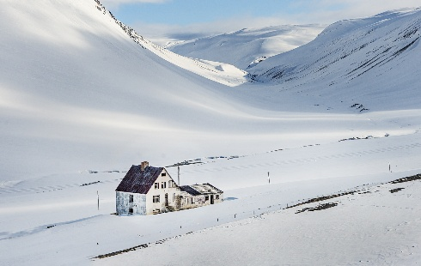  Abandoned Farm, Iceland
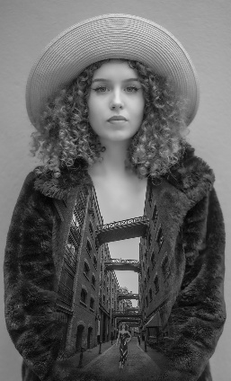  Model Interior | 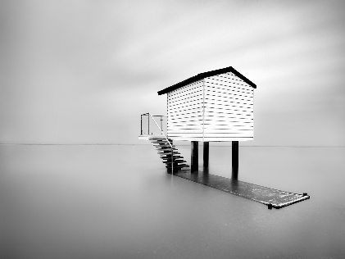  Room with a View
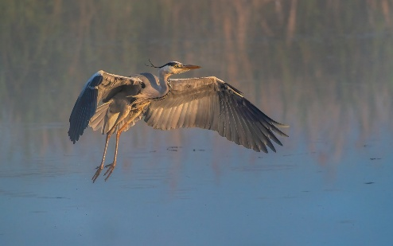  Grey Heron in Flight | 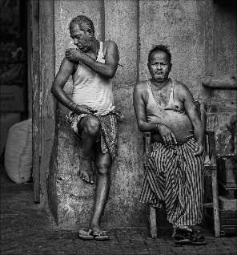  Just Chilling
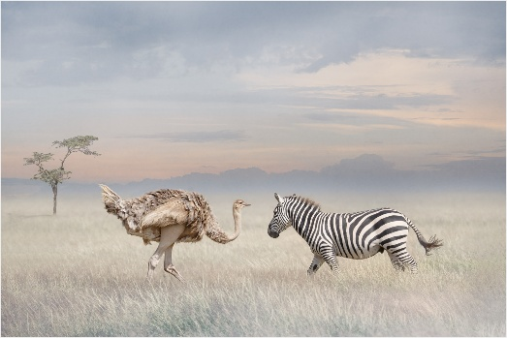  Chance Encounter | 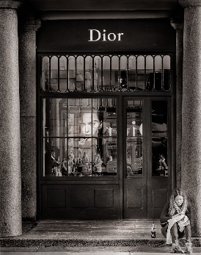  The Girl, a Coke Bottle and the Face of Dior

The next external competition is at Halstead on Thursday 12th November – please make contact if you would like to come.

Andrew Bailey
External Competition Secretary

