PAGB Inter Club PDi Championship 2026

On Sunday 19th July, the PAGB Inter Club PDi Championship 2026 was held at Warwick. This was the first time Colchester had qualified for this event in quite a while and our available image bank was strong. Unfortunately our strong set of people pictures were rendered unusable by the unexpectedly low scores (typically 10) that even very good people shots were getting. With very good landscape also only getting 12 marks, this left us just short of the top ten clubs after round 1 and a real selection dilemma for round 2 where we needed to get some high scores to secure a place in the final round by finishing in the top 8. Unfortunately these selections didn’t really lead to the improvement we needed and we remained 11th overall at the end of the first two rounds.
In an attempt to increase the number of 13+ scores in the plate competition I entered 5 new images out of the 8 required (the rules state you must enter at least 4 new images). Every image did well and we scored seven 12s and one 13, coming 3rd, narrowly missing out on winning by 2 marks. Annoyingly two of our images that got 13 in the first round went down to 12 in the plate and although one went from 12 to 13 we just needed a couple of high scoring images (14s or 15s) to achieve top spot.
Congratulations to the following authors who achieved a 13 for their images

Chris Aldred ‘Room with a View’
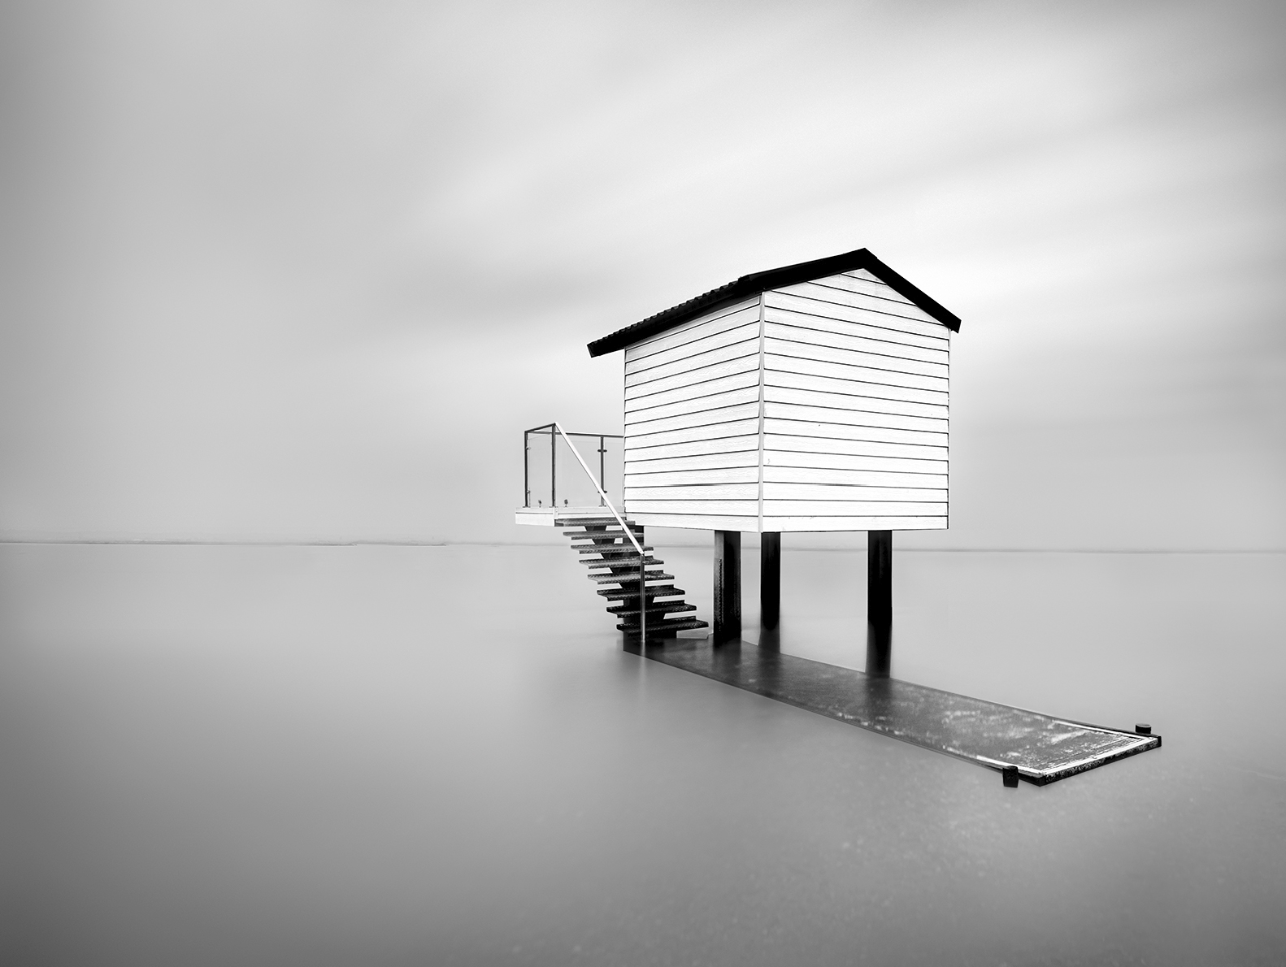

Roy Essery ‘At Home with Julio Napolis’

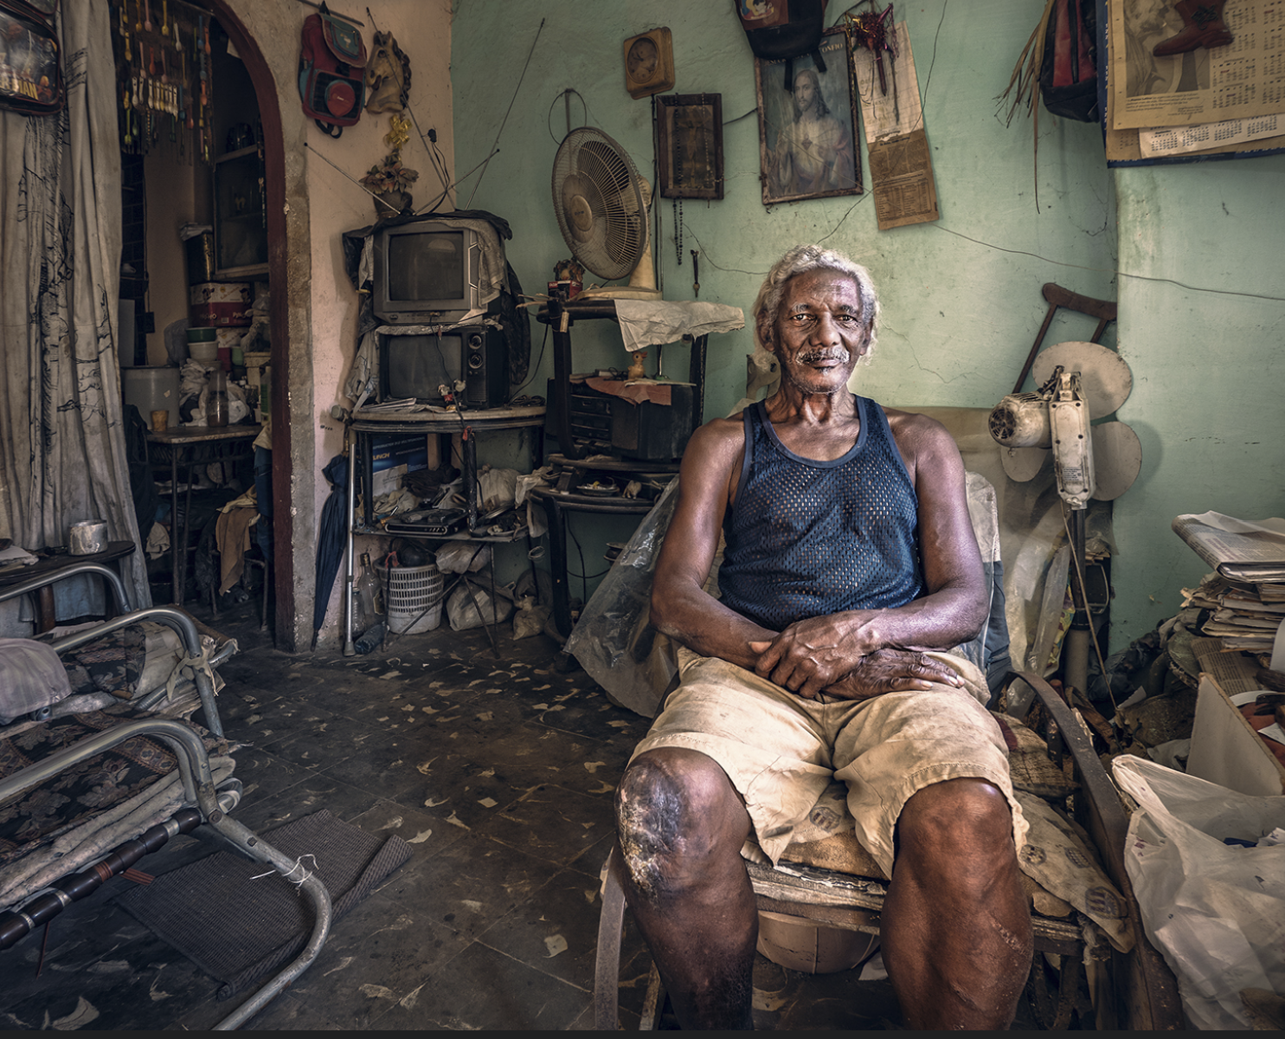
Derek Howes ‘Snow Leopard on top of his world’
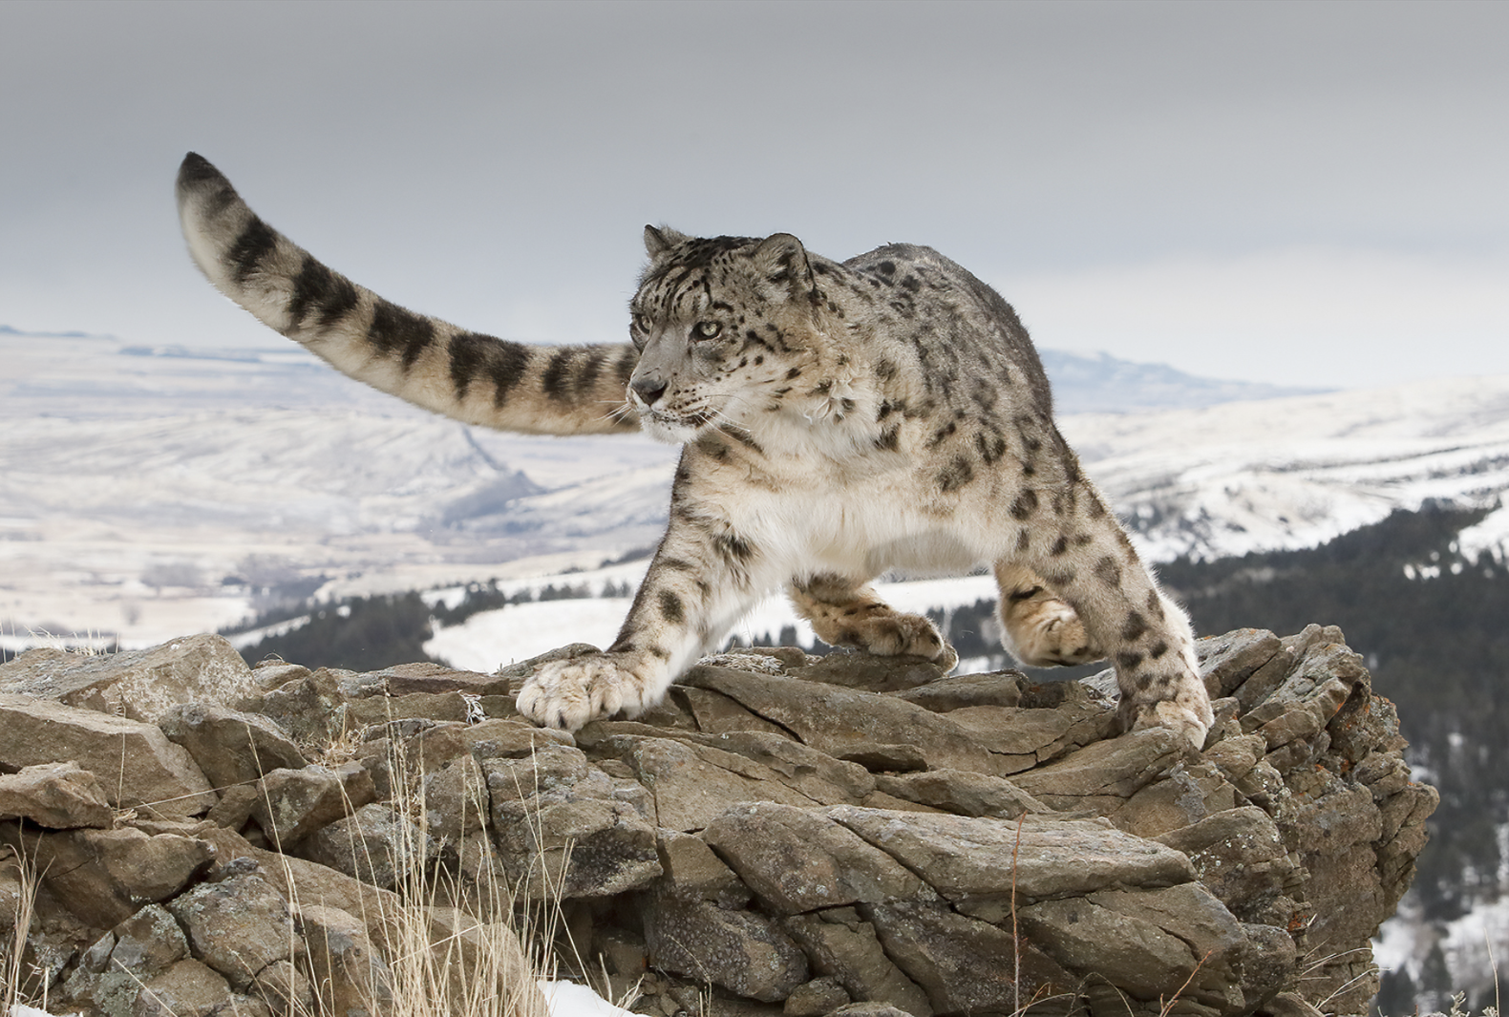

Chrissie Hart ‘Chance Encounter’

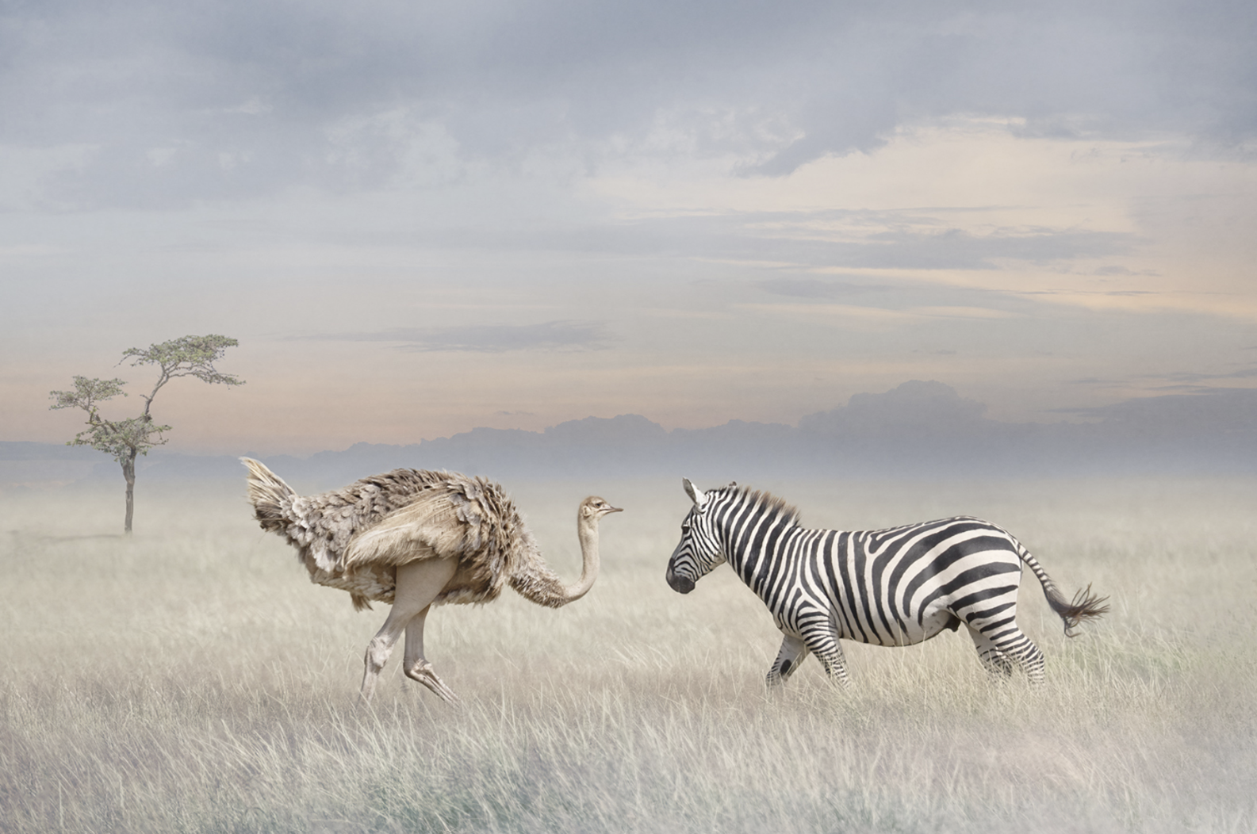

The standings in the final were

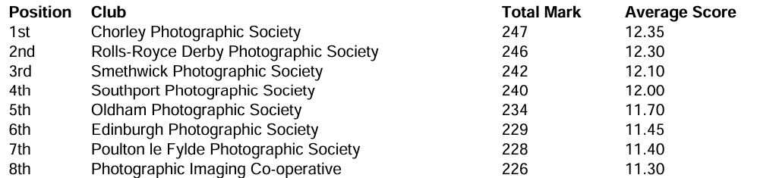

The standings in the Plate Competition were

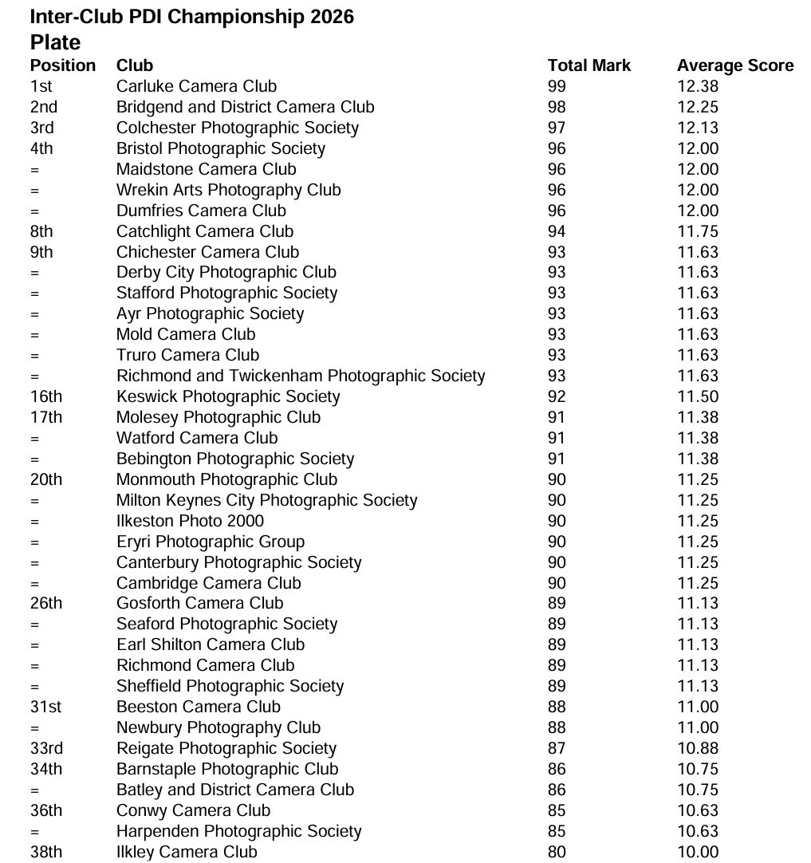

Annoyingly, I believe we would have maintained our average score had we got into the final and that would have placed us in a very high position in the competition as a whole.

Our individual scores were

Round one (11th)
01 | Elephant and Calf | Chrissie Hart | 11
02 | Squabbling starlings | Chris Aldred | 12
03 | The Guardians | Colin Westgate | 11
04 | At Home wth Julio Napolis | Roy Essery | 13
05 | Herringfleet Mill in Freezing Fog | Andrew Bailey | 12
06 | Discarded | Roy Essery | 10
07 | Chance Encounter | Chrissie Hart | 13
08 | Abandoned Farm, Iceland | Colin Westgate | 12

Round Two (11th)
01 | Room with a view | Chris Aldred | 12
02 | Fighting Fieldfares | Robert Macdonald | 12
03 | Snow Leopard on Top of His World | Derek Howes | 13
04 | On the edge of the mist | Andrew Bailey | 12
05 | Enchanted Forest | Andrew Bailey | 10
06 | Shall we Dance? | Chris Pugh | 12
07 | Flo all of a Flutter | Chris Pugh | 10
08 | Stokksnes, Iceland | Colin Westgate | 10

Plate Competition
01 | Room with a view | Chris Aldred | 13
02 | The Pounce – Arctic Wolves | Derek Howes | 12
03 | Gale Force 8 | Shaun Hykel | 12
04 | Territorial Dispute | Chris Aldred | 12
05 | Winter Morning, Dedham Vale | Andrew Bailey | 12
06 | At Home with Julio Napolis | Roy Essery | 12
07 | Geese at Herringfleet Mill | Andrew Bailey | 12
08 | Chance Encounter | Chrissie Hart | 12

Please do alert and send to me any images that you feel are suitable for use during the coming season. Our first competition is our own 8 by 8 competition on Tuesday 20th October and this is followed almost immediately by the PAGB Print Championships which take place on the 24th October. We need to find more high scoring images!

Andrew Bailey – External Competition Secretary

