Colchester Photographic Society
Mersea Island Challenge Trophy

All rounds of the Mersea Island Challenge Trophy have now been completed and I am delighted to be able to report that Colchester were the top scoring club in the 12 rounds of this year’s competition. The full results are in the table below.

 | Club | Total | Average
1 | Colchester PS | 1107 | 18.5
2 | Selby | 1078 | 18.0
3 | Norwich and District | 1062 | 17.7
4 | North Norfolk | 1037 | 17.3
5 | X Rolls Royce | 1035 | 17.3
6 | Dingwall | 1032 | 17.2
7 | Dalston | 1030 | 17.2
8 | South Liverpool | 1004 | 16.7
9 | Mersea | 973 | 16.2
10 | Rochdale | 959 | 16.0
11 | Ivybridge | 945 | 15.8
12 | East Ipswich | 935 | 15.6

Our six images fared as follows

Title | Author | Total | Average
The Pounce – Arctic Wolves | Derek Howes | 223 | 18.6
Territorial Dispute | Chris Aldred | 227 | 18.9
The Guardians | Colin Westgate | 211 | 17.6
Herringfleet Mill in freezing fog | Andrew Bailey | 229 | 19.1
Fighting Fieldfares | Robert Macdonald | 217 | 18.1
Discarded | Roy Essery | 220 | 18.3

Our images scored consistently very highly, with ‘Herringfleet Mill’ and ‘Territorial Dispute’ both in the top 5 scoring images from all club entries, closely followed by ‘The Pounce – Arctic Wolves’. ‘Discarded’ was the top scoring of the tiebreak images from all clubs.
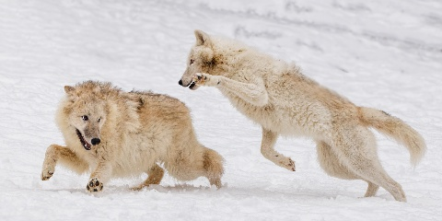  The Pounce – Arctic Wolves  Derek Howes | 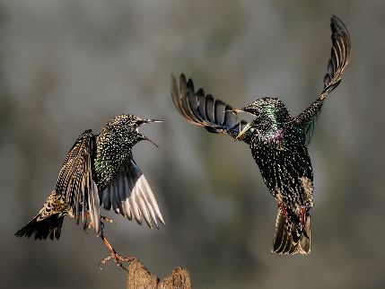  Territorial Dispute  Chris Aldred | 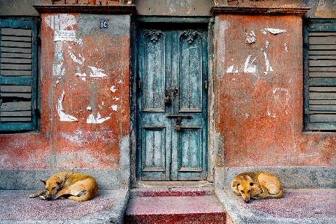  The Guardians  Colin Westgate
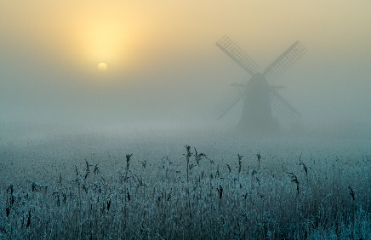  Herringfleet Mill in  Freezing Fog  Andrew Bailey | 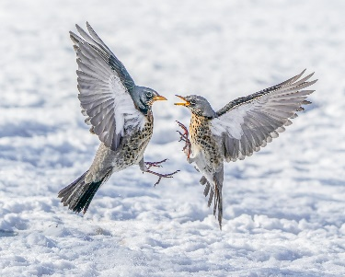  Fighting Fieldfares  Robert Macdonald | 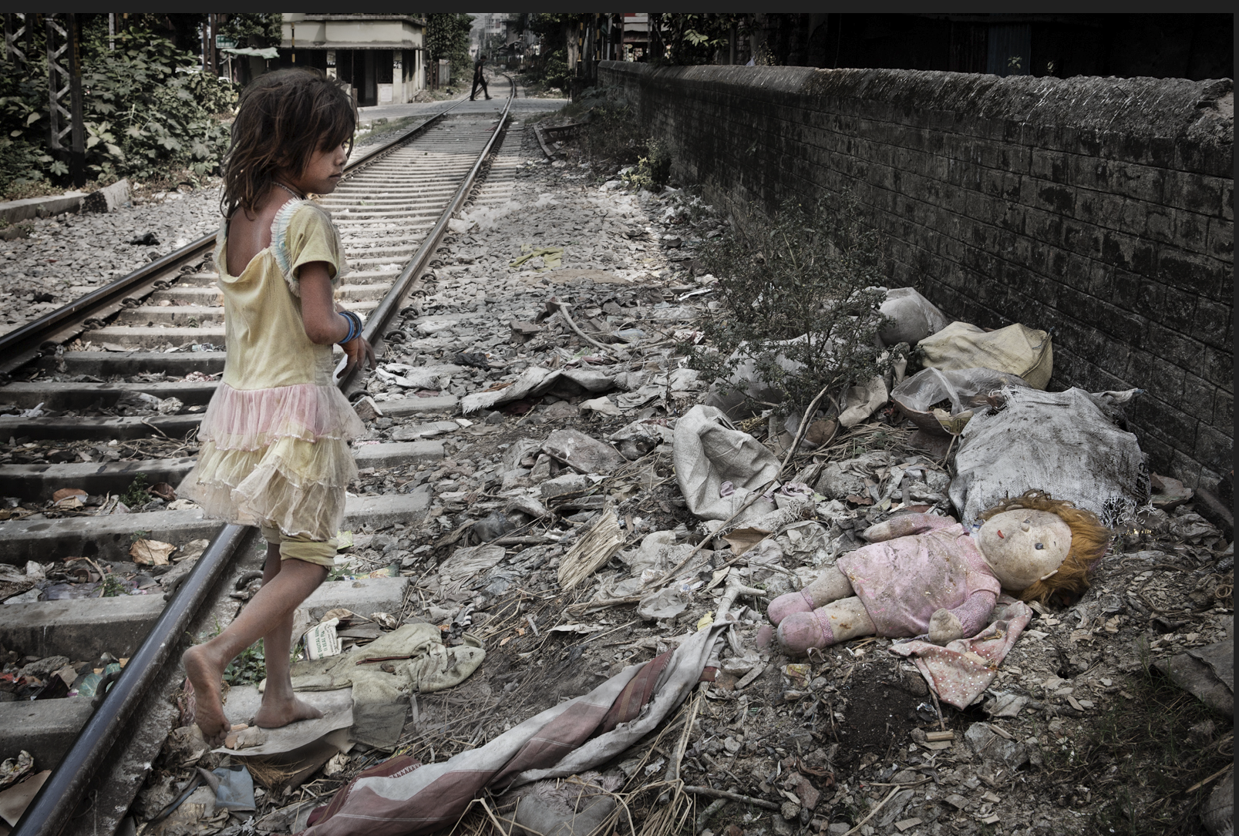  Discarded  Roy Essery

We will see if we can defend the title in next year’s competition!

Andrew Bailey

External Competition Secretary

