GB Cup
We came equal 9th out of 46 clubs, a solid performance with some notable clubs below us (as well as above us!)
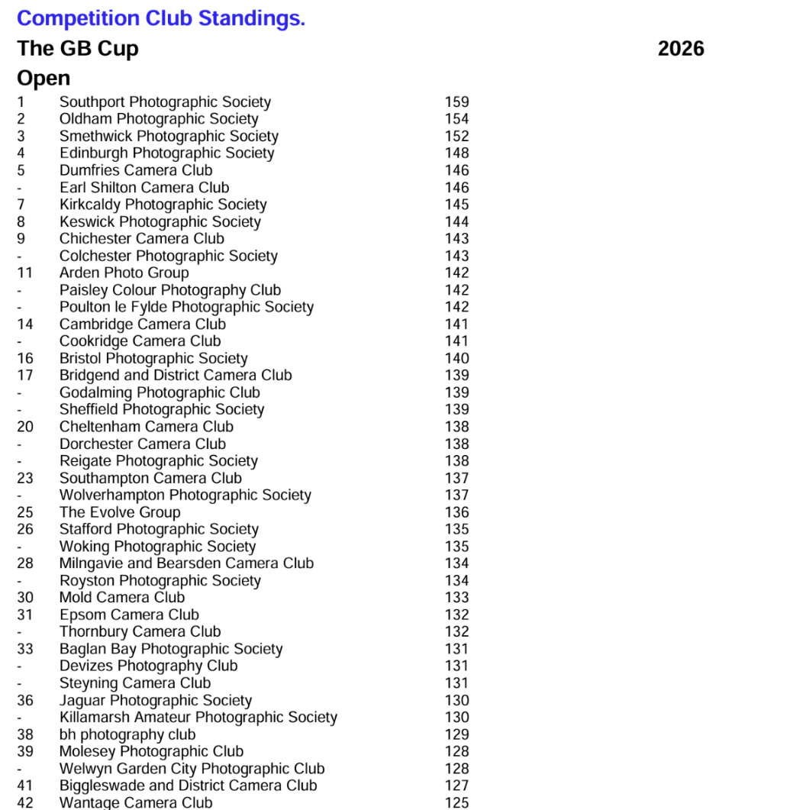

Our images fared as follows:
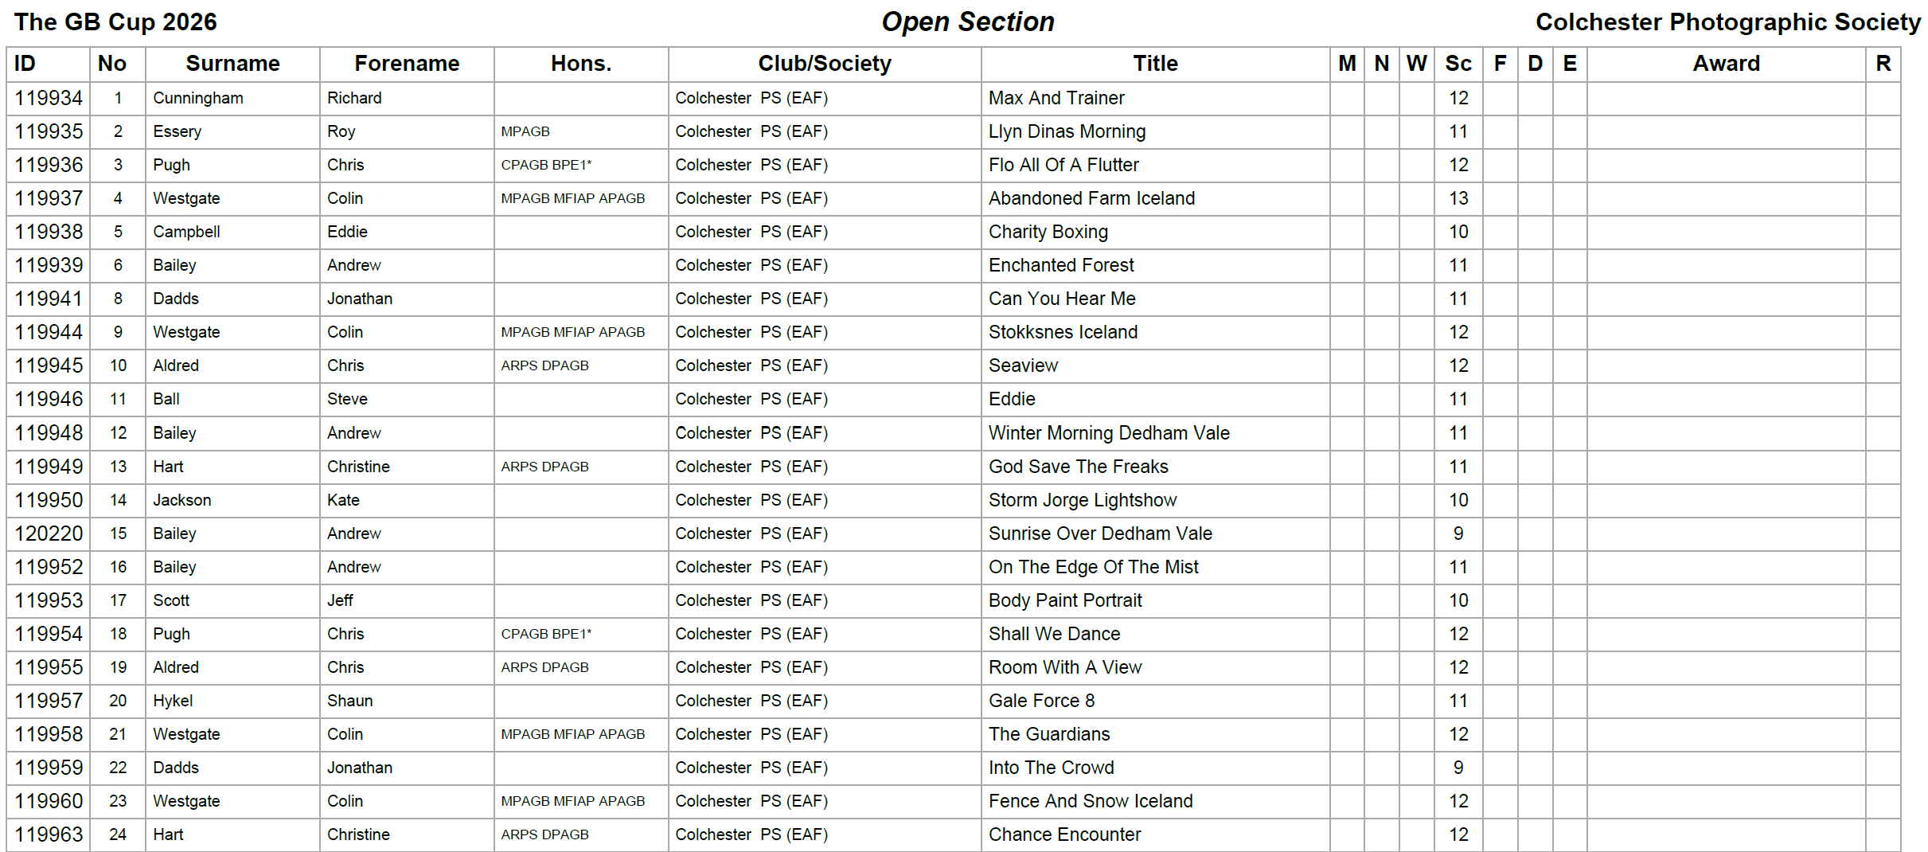

GB Nature Cup
We came equal 8th out of 54 clubs, one mark behind equal 3rd and two marks behind 2nd place. Congratulations to Derek Howes who picked up a PAGB Ribbon for The Pounce – Arctic Wolves. Although we didn’t have lots of high scores, the marking was quite tough and a score of 12 was a good score in this competition.

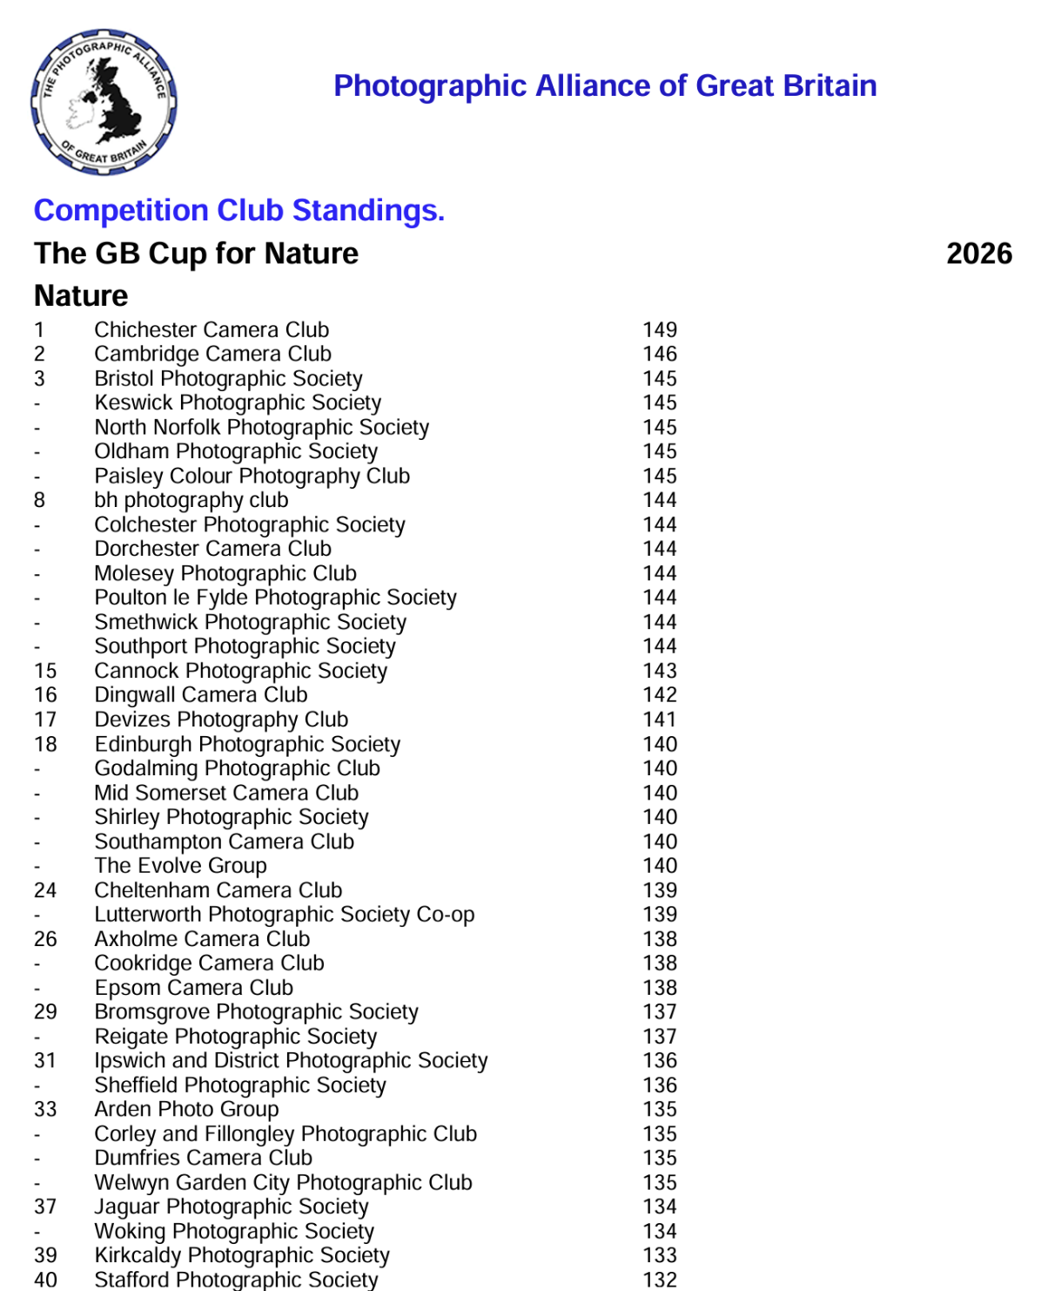

Our images fared as follows

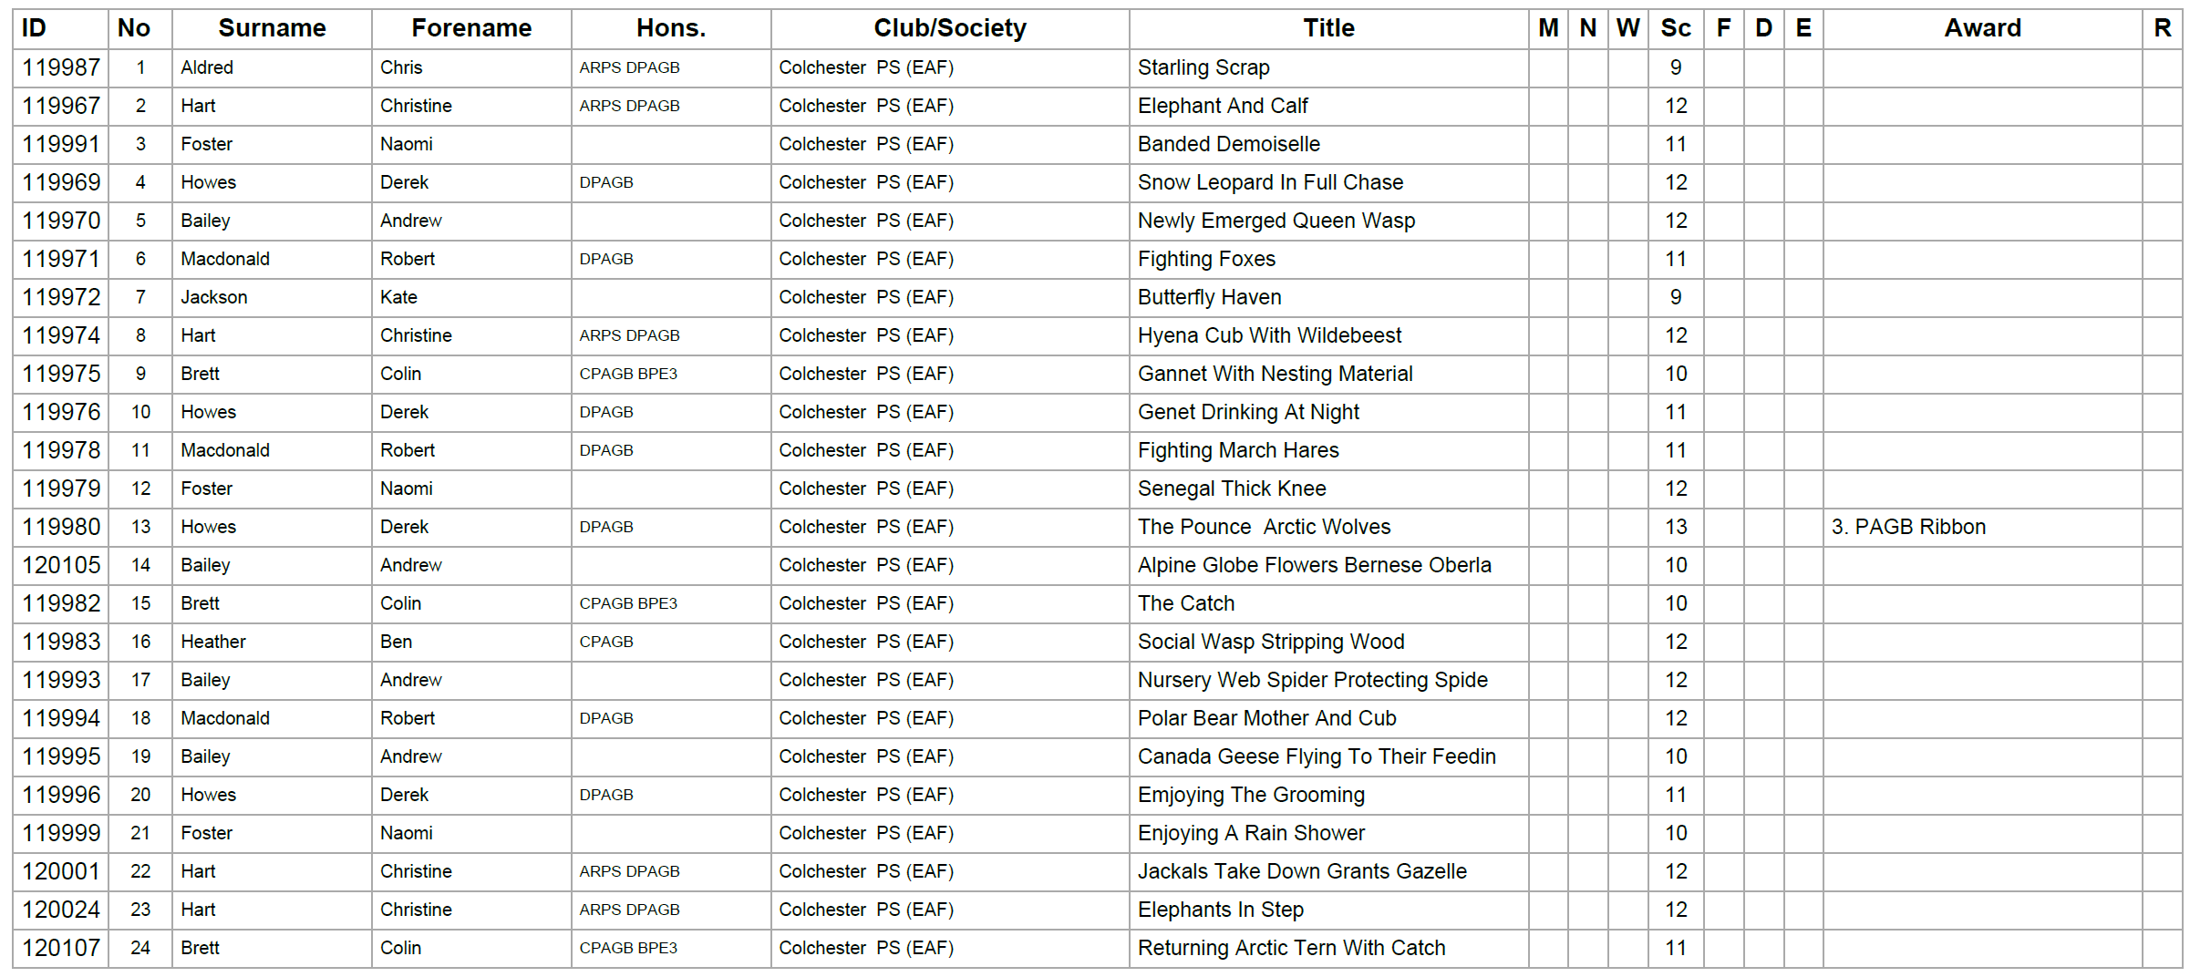

Both competitions provide us with useful feedback on images as we begin to look forward to the PDi National Championship of Great Britain at Warwick to be held on the 19th July.
Well done to all authors who had images selected.

Andrew Bailey

External Competition Secretary

