On Monday 13th April, we travelled to Ipswich for our Annual Battle. The competition consists of 15 prints and 15 pdi images with a maximum of one per author across the entire competition.

In a keenly contested first half, we tied the prints with 137.5 marks each. The judge decided to spread the marks a little more in the second half and we won the pdi section , scoring 130.5 marks to 125.5.

The final positions were

 | Prints | PDI | Totals
Colchester | 137.5 | 130.5 | 268
Ipswich | 137.5 | 125.5 | 263

Congratulations to the following authors who scored the maximum mark of 10 on the evening, Chrissie Hart for ‘Chance Encounter’, Shaun Hykel for ‘Beautiful Autumn Colours’, Ben Heather for ‘Social Wasp Stripping Wood’ and Andrew Bailey for ‘On the edge of the mist’.
  Chance Encounter | 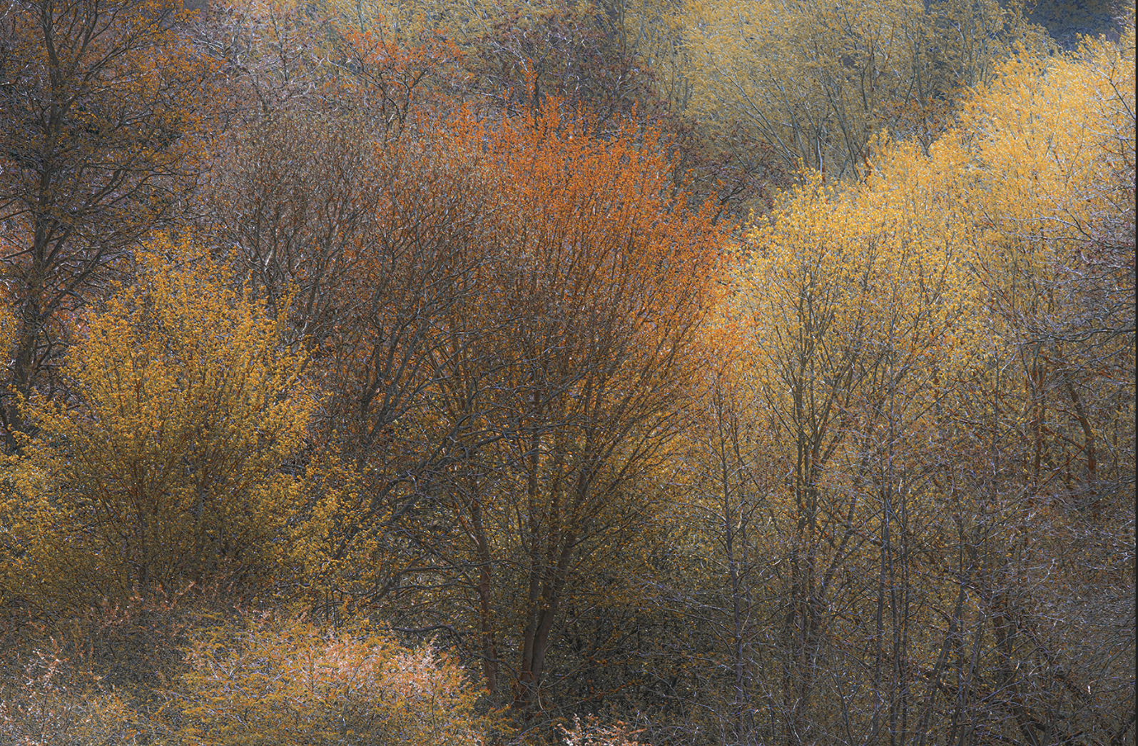  Beautiful Autumn Colours | 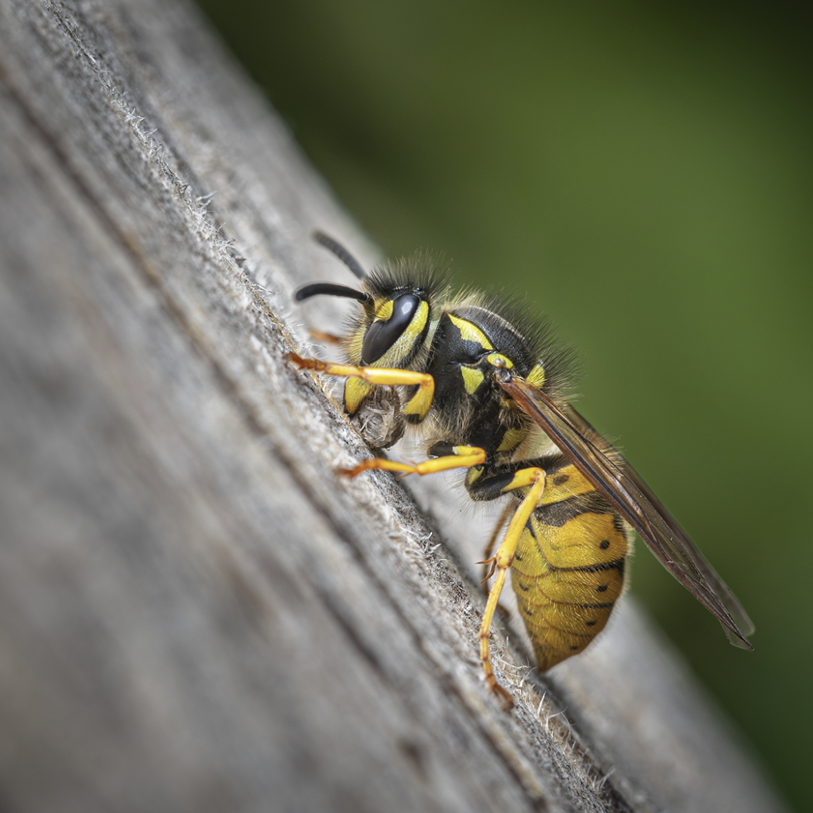  Social Wasp Stripping Wood | 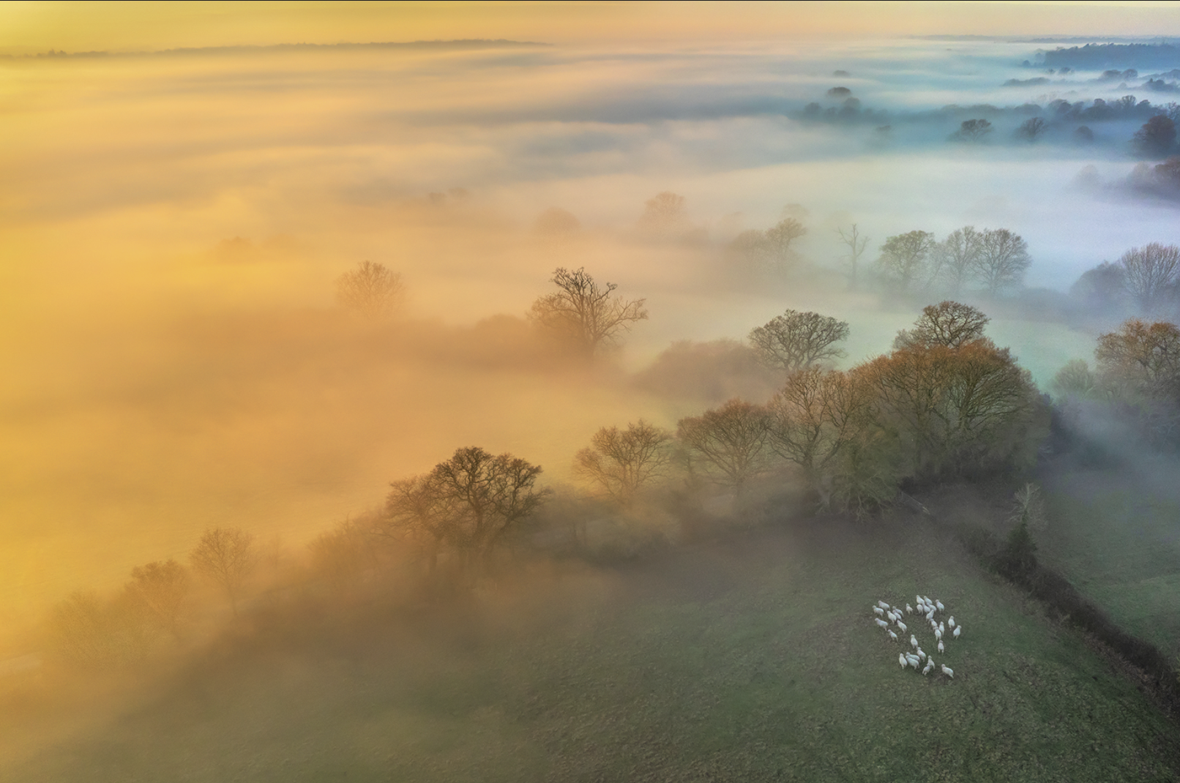  On the edge of the mist

The scores for all of our images were as

Prints
Whitby Abbey | Peter Pangbourne | 9
Senegal Thick Knee | Naomi Foster | 9.5
The end of the Voyage | Mark Kench | 9.5
Legal and General | Matt Biggin | 9.5
Chance Encounter | Chrissie Hart | 10
Gannet with nesting material | Colin Brett | 8.5
Veiled Thoughts | Chrissie Alexander | 9.5
Aladdin | Roy Essery | 9
Red Fox | Derek Howes | 9
Room with a view | Chris Aldred | 8.5
Seeking Enlightenment | Kate Jackson | 9
Model Interior | Jeff Scott | 9.5
The Guardians | Colin Westgate | 9.5
Fighting Fieldfares | Robert Macdonald | 9
Summer meadow cyanotype | Katherine Bailey | 8.5
PDIs
Henley Sunrise | David Charlton | 8.5
Head and Tail | Eddie Campbell | 8.5
Sunny Point groyne | Clifford Sullivan | 7
Up, Up and away | Clare Carter | 7.5
Charging Tree | Ian Carter | 7.5
Flo all of a flutter | Chris Pugh | 9
Mother and Child | Alan James | 8
Beautiful Autumn Colours | Shaun Hykel | 10
Max and Trainer | Richard Cunningham | 9.5
Up Up and away | Hilary Knight | 8.5
On the edge of the mist | Andrew Bailey | 10
Migrant Hawker on the Hunt | Jan Cross | 9
Social wasp stripping wood | Ben Heather | 10
Can you hear me | Jonathan Dadds | 9
One New Change Shopping Centre | Steve Ball | 8.5

Our next external competition is the National Finals of the PDI Championships of Great Britain, to be held at Warwick on the 19th July. This is sure to be a high quality event and a day to look forward to.

Andrew Bailey

External Competition Secretary

