Colchester Photographic Society
Braintree Mono Shield
Judge: Barbie Lindsay

On Tuesday 3rd March we travelled south to Braintree for the Braintree Mono Challenge. The competition comprises six monochrome prints from each club. Five of our six prints were held back and the judge seemed to react very favourably to our work. The final scores were

1 | Colchester PS | 54.5
2 | Chelmsford | 52
3 | Maldon | 50.5
4 | Halstead | 49.5
5 | Clacton | 46
6 | Dunmow | 45
6 | Great Notley | 45
8 | Springfield | 44.5
9 | Braintree | 43
10 | Pierrefitte | 42

Our six images fared as follows

Gale Force 8 | Shaun Hykel | 8.5
Model Interior | Jeff Scott | 10
Julio Napolis and Friend | Roy Essery | 10
Destitution Road | Colin Westgate | 8
Protection | Chrissie Hart | 9
Seeking Enlightenment | Kate Jackson | 9

‘Model Interior’ and ‘Julio Napolis and Friend’ were two of only four prints that were given maximum marks on the evening.

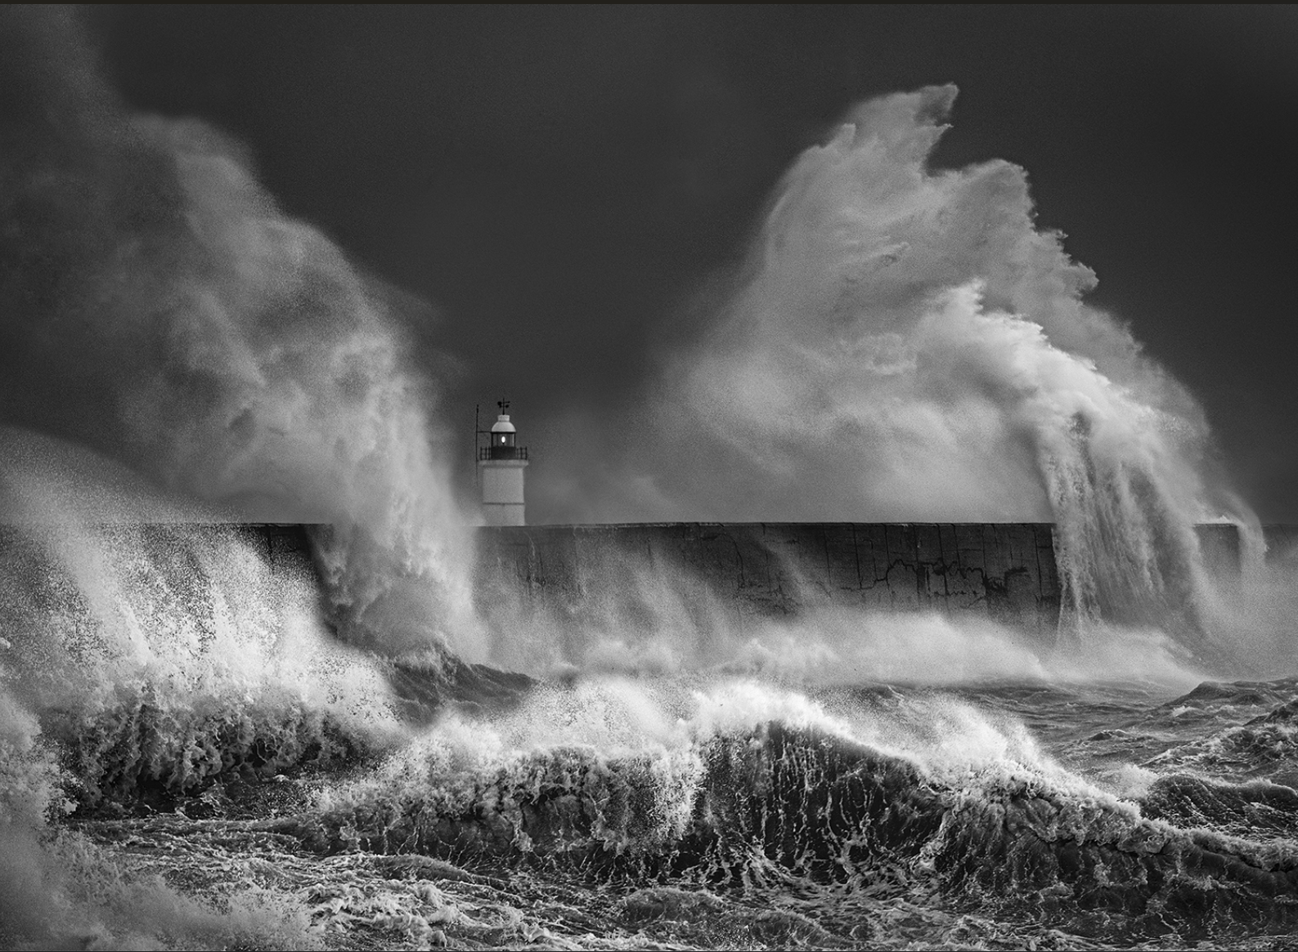  Gale Force 8  Shaun Hykel | 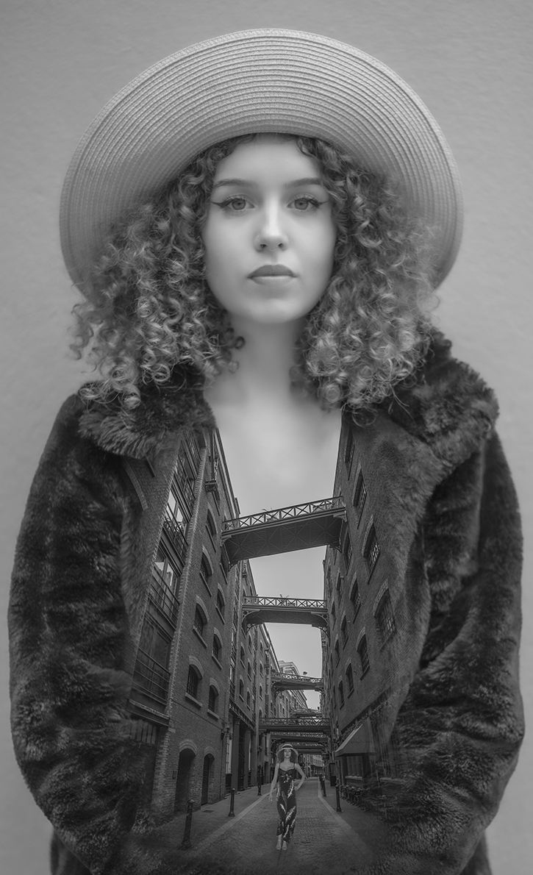  Model Interior  Jeff Scott | 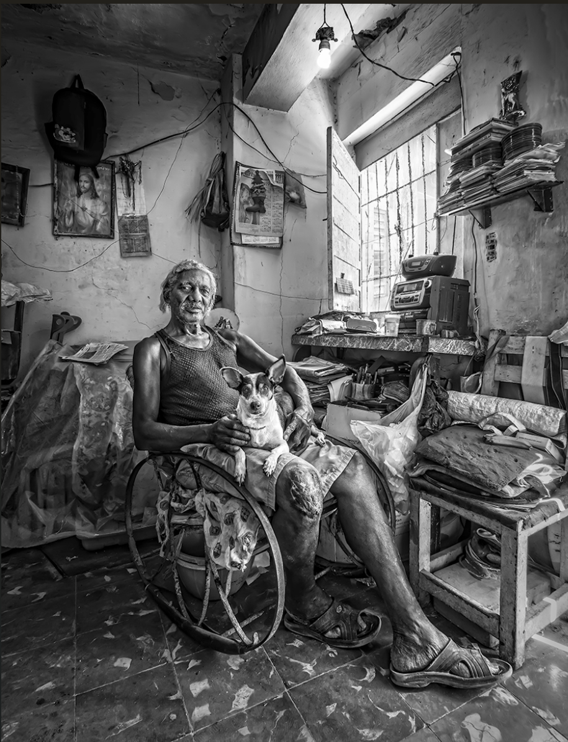  Julio Napolis and Friend  Roy Essery
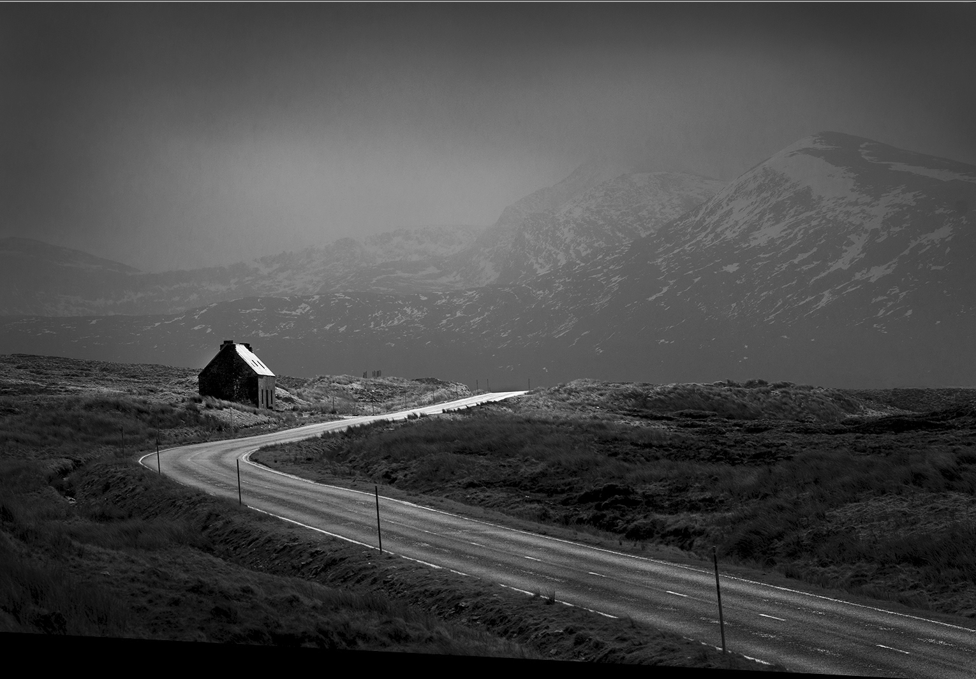  Destitution Road  Colin Westgate | 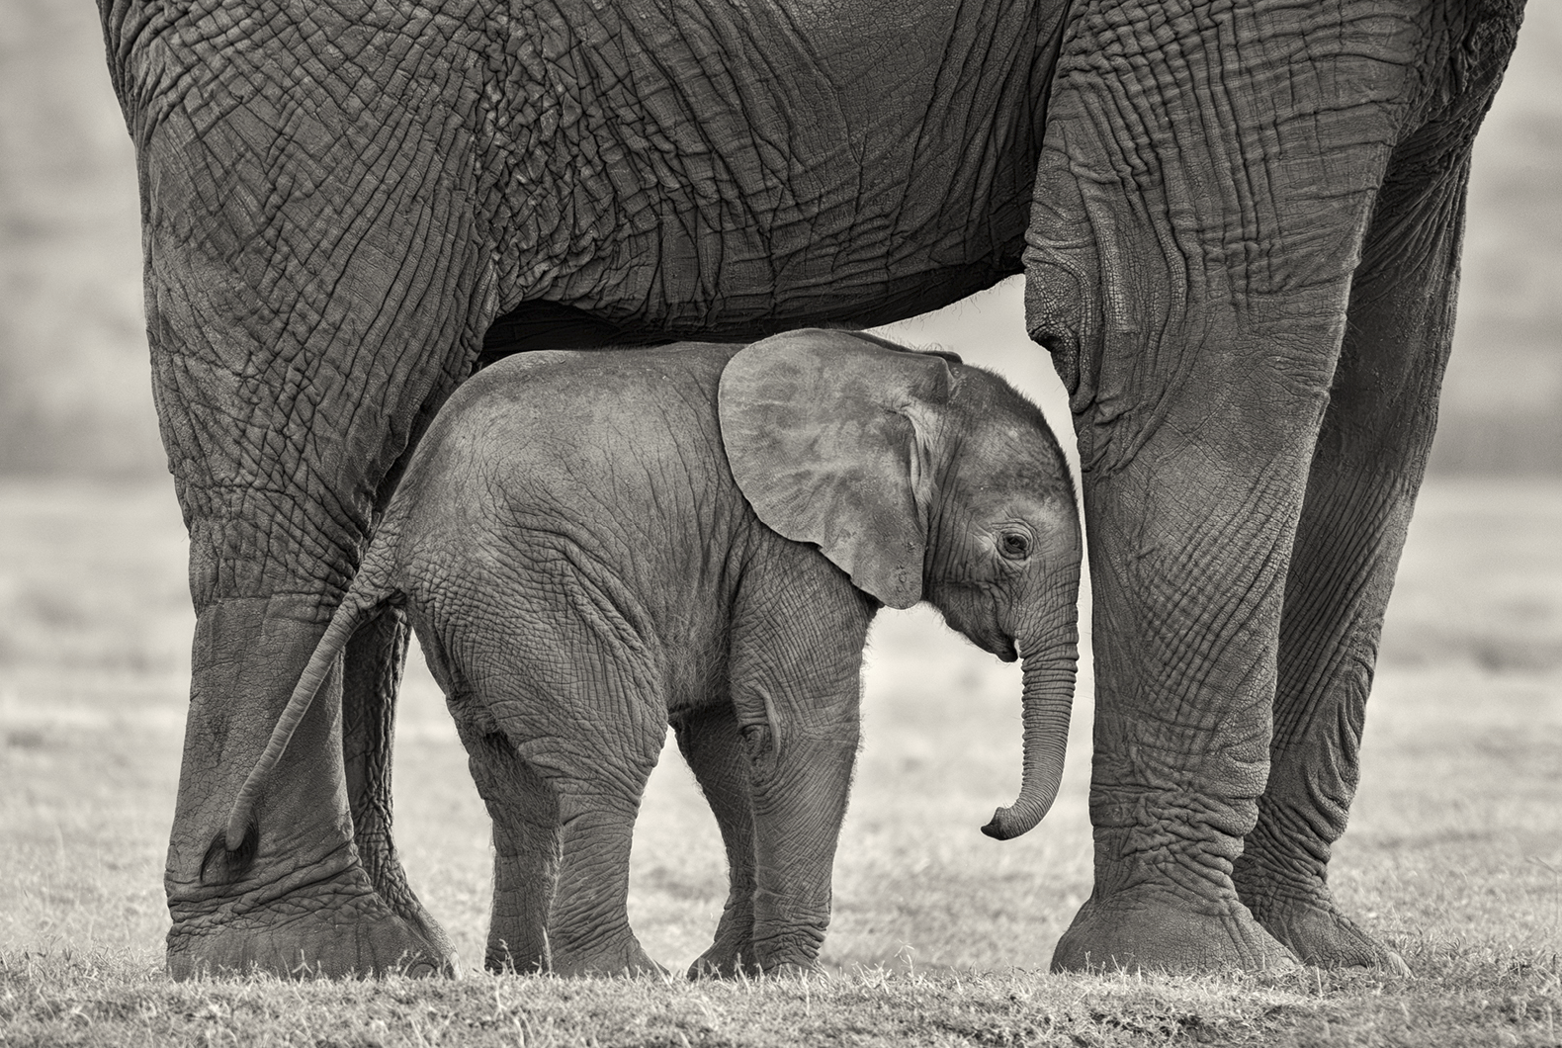  Protection  Chrissie Hart | 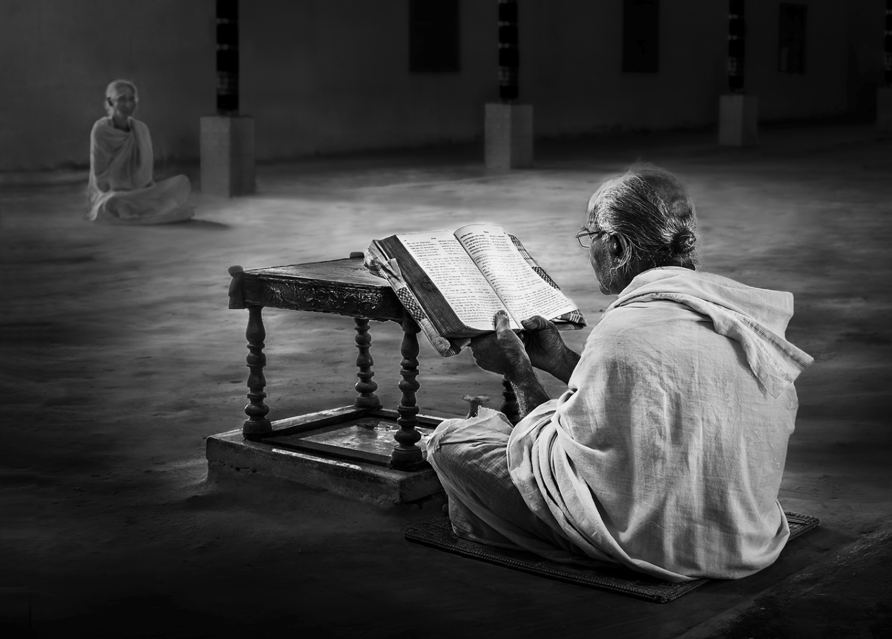  Seeking Enlightenment  Kate Jackson

Congratulations to all authors for having their work selected.

Andrew Bailey

External Competition Secretary

